**Bug Report**

Summary: Only unique brand name should be displayed

Priority = 4

Steps:

1. Login to Shipt and switch to Target store
2. Click “Browse”
3. Select “Sporting Goods & Outdoors” category
4. Select “Coolers and Water Bottles” sub category
5. Verify the “Brand Names”

Actual Result: Brand Name Contigo displayed twice

Expected Result: Duplicate Brand Name should not be displayed

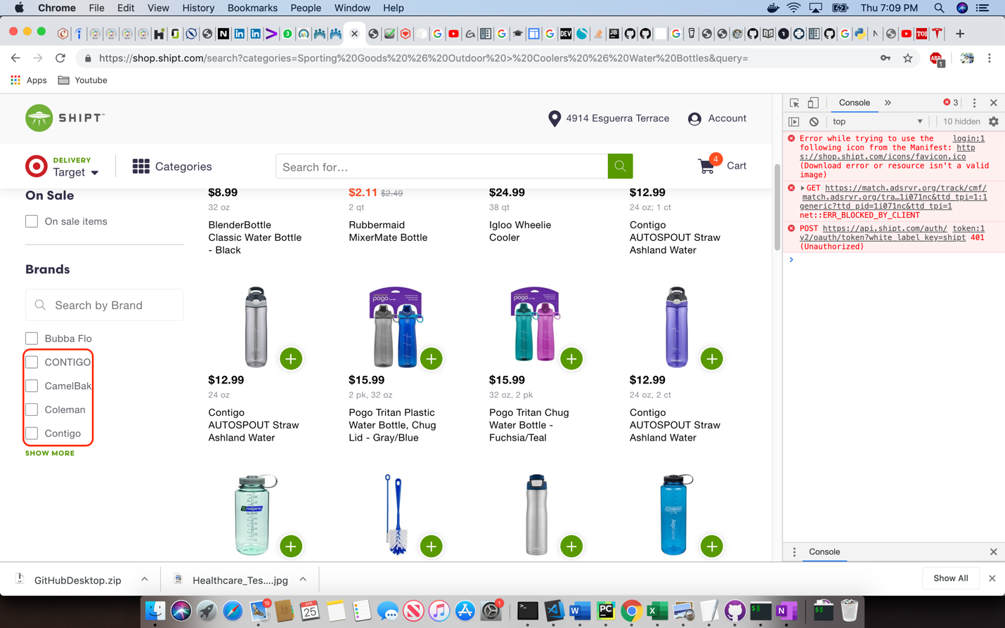

What are the possible reasons for the following defect? How would you go about debugging the problem and gathering more information?

This could be because of the different case. Application should handle brand name case insensitively in UI layer.